Computer Networks – Assignment 1

Make the Data of a Smart Manufacturing Plant Arrive Correctly and On Time
Name | Ch Venkata Puneeth
Register No. | 1925260234
Course | CSA0707 – Computer Networks, CSE (AI & ML), SIMATS Engineering
Assignment | 1 – Individual – 50 marks – CO1 – Bloom K5 (Evaluate)
GitHub repository | https://github.com/grininjap3/computer-networking.git

Task 1 – Size the Traffic Before Choosing Anything
Assumptions: rates are payload rates (headers ignored at first); every line is identical, including its 150 office users.
Source | Working | Traffic
Robot controllers | 1 / 0.002 s = 500 commands/s × 200 B × 8 = 800 kbps each; × 40 | 32.00 Mbps
Vibration sensors | 600 × 50 B/s × 8 = 240,000 bps | 0.24 Mbps
CCTV cameras | 24 × 4 Mbps | 96.00 Mbps
Office users | 150 × 2 Mbps × 10 % | 30.00 Mbps
One line | 32 + 0.24 + 96 + 30 | 158.24 Mbps
Plant (8 lines) | 8 × 158.24 | 1,265.92 Mbps ≈ 1.27 Gbps
(If the 150 office users are shared by the whole plant instead: 8 × 128.24 + 30 = 1,055.92 Mbps – still above 1 Gbps.)
Largest sender vs strictest delay. CCTV sends the most (96 Mbps = 60.7 % of the line). The robots have the strictest delay (10 ms) but send only 32 Mbps (20.2 %). They are not the same source: volume and urgency are different problems.
Is a 1 Gbps uplink enough? One line needs 158.24 Mbps = 15.8 % of 1 Gbps – fine. The whole plant needs 1,265.92 Mbps = 126.6 % – not enough. Adding Ethernet/IP/TCP headers (a 200-byte command becomes 258 bytes on the wire, +29 %) makes it worse.
CCTV in the same queue as robot commands. Once offered load exceeds the link rate, the queue fills and every packet waits behind video. Queueing delay = queued bytes ÷ link rate: a 1 MB buffer at 1 Gbps adds 8 ms, a 2 MB buffer adds 16 ms – already more than the 10 ms deadline – and when the buffer is full packets are dropped. At the robot rate of 500 commands/s, a 100 ms stall = 50 missed commands. Fix: separate VLANs plus strict-priority queueing (802.1p / DSCP EF) for robot traffic, and a faster uplink.
Delay-versus-volume comparison
Traffic | Volume (per line) | Delay it tolerates | Main requirement
Robot commands | 32 Mbps (20 %) | 10 ms | bounded delay, no loss
Vibration sensors | 0.24 Mbps (0.2 %) | ~100s of ms | reliability, low cost
CCTV | 96 Mbps (61 %) | 100s of ms with buffering | bandwidth, low jitter
Office / ERP | 30 Mbps (19 %) | ~100 ms–seconds | bandwidth, fairness
Ranking by harm of a 100 ms delay (worst first)
- Robot commands – the deadline is 10 ms, so 100 ms is 10× too late (50 commands missed): collisions, scrap, safety hazard.
- CCTV – live video would freeze or jump; buffering (4 Mbps × 0.1 s = 50 KB per camera) hides some of it, but real-time analytics and alarms degrade.
- Vibration sensors – one reading per second, so 100 ms is only 10 % of the period; harmful only for a fast machine-protection alarm.
- Office/ERP – users notice 100 ms but still work; no physical consequence.
Alternative concept – motion-triggered CCTV (5 % of the time)
CCTV = 96 × 0.05 = 4.8 Mbps per line. Line total = 32 + 0.24 + 4.8 + 30 = 67.04 Mbps; plant = 8 × 67.04 = 536.32 Mbps (53.6 % of 1 Gbps). The 1 Gbps uplink is no longer the bottleneck; robots become the largest source (47.7 % of the line). Local recording needs storage instead: 96 Mbps = 12 MB/s ≈ 1.04 TB per line per day. For five plants the aggregate would be 5 × 536.32 = 2.68 Gbps, so the uplink bottleneck returns at scale (10 Gbps needed).

Runnable Python example – Task 1
robot_mbps = 40 * (1 / 0.002) * 200 * 8 / 1_000_000
sensors_mbps = 600 * 50 * 8 / 1_000_000
cctv_mbps = 24 * 4
office_mbps = 150 * 2 * 0.10
line_total = robot_mbps + sensors_mbps + cctv_mbps + office_mbps
plant_total = 8 * line_total
print(f"Robots: {robot_mbps:.2f} Mbps")
print(f"Sensors: {sensors_mbps:.2f} Mbps")
print(f"CCTV: {cctv_mbps:.2f} Mbps")
print(f"Office: {office_mbps:.2f} Mbps")
print(f"One line: {line_total:.2f} Mbps")
print(f"Eight-line plant: {plant_total:.2f} Mbps")

OUTPUT SCREENSHOT – TASK 1
.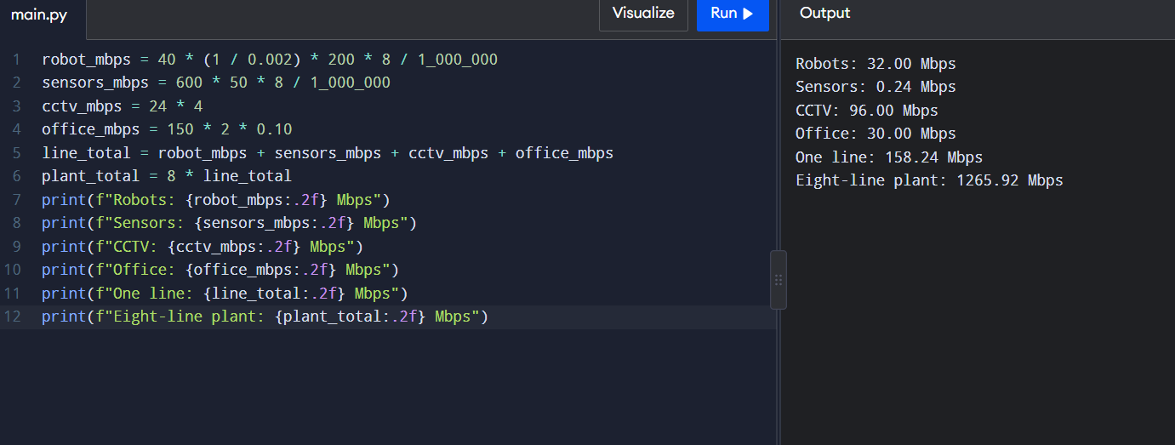

Task 2 – Count the Domains in the Contractor's Drawing
Marked drawing (CD = collision domain, BD = broadcast domain)
PC1-PC8 ──── HUB1 ──┐ (CD1)
PC9-PC16 ──── HUB2 ──┼── SWITCH-A (24 ports) ──── G0/0 [ ROUTER ] G0/1 ──── SWITCH-B ──── 12 IP phones
PC17-PC24 ─── HUB3 ──┘ (CD2, CD3) (CD4) (CD5) (CD6 … CD17, one per phone)
|<------------------ BD 1 ------------------>| |<----------------- BD 2 ----------------->|
- Collision domains = 17: each hub with its 8 PCs and its link to the switch (3), switch-A to router G0/0 (1), router G0/1 to switch-B (1), one per phone port on switch-B (12). 3 + 1 + 1 + 12 = 17.
- Broadcast domains = 2: the router separates them. BD1 = hubs + switch-A + G0/0; BD2 = G0/1 + switch-B + phones.
Layer of each device
Device | OSI layer | Why
Hub | 1 – Physical | repeats electrical bits to every port; knows nothing about frames
Switch | 2 – Data link | reads MAC addresses and forwards per port
Router | 3 – Network | reads IP addresses, separates broadcast domains
PC / IP phone | 1–7 (end systems) | run the full stack
Why a hub cannot stop collisions: it has no frame buffer or MAC table; it regenerates every signal on all other ports, so all 8 PCs share one medium and CSMA/CD half-duplex rules apply. Two simultaneous senders always collide.
Point-to-point vs multipoint: switch-A–router, router–switch-B and each phone–switch-B link are point-to-point (full duplex, no sharing). Each hub segment (8 PCs + the uplink) is logically multipoint (shared medium) even though each cable is physically point-to-point.
Standards table
Technology | Standard | Defining body
Ethernet | IEEE 802.3 | IEEE (LAN/MAN Standards Committee)
Wi-Fi | IEEE 802.11 (Wi-Fi Alliance certifies) | IEEE
IPv4 | RFC 791 | IETF
OSI model | ISO 7498 (ISO/IEC 7498-1) | ISO
5G | 3GPP Release 15 onward; IMT-2020 | 3GPP and ITU-R
The plant should buy only standard-compliant equipment for interoperability between vendors, no lock-in, predictable behaviour, certified safety/EMC performance and an upgrade path when it grows from 40 to 1,500 devices and then to 5 plants.
Alternative concept – replace the hubs with unmanaged switches
Collision domains become 24 (one per PC port) + 3 (switch-to-switch links) + 1 + 1 + 12 = 41. Broadcast domains stay 2.
Fixes: collisions on the PC segments, half-duplex waiting, shared 100 Mbps (each PC gets a dedicated full-duplex port). Does not fix: broadcast domain size (still all 24 PCs + switch in BD1), no VLANs, no QoS for robot traffic, no security/port control or monitoring, no loop protection (unmanaged switches usually lack STP), still a single uplink to the router.

Runnable Python example – Task 2
collision_domains = 3 + 1 + 1 + 12
broadcast_domains = 2
print("Collision domains:", collision_domains)
print("Broadcast domains:", broadcast_domains)
print("With one switch port per PC, collision domains become:", 24 + 3 + 1 + 1 + 12)

OUTPUT SCREENSHOT – TASK 2
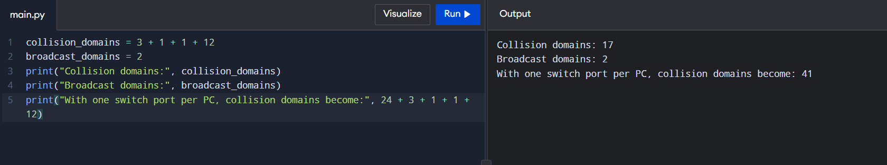

Task 3 – Read a Captured Frame Layer by Layer
Capture line | OSI layer | PDU
Ethernet II (MACs, Type 0x0800) | 2 – Data link | Frame
IPv4 (10.10.1.25 → 10.10.9.4, TTL 61) | 3 – Network | Packet
TCP (51522 → 502) | 4 – Transport | Segment
Modbus write-register, 12 bytes | 5–7 – Application | Data / message
Routers crossed: each router decrements TTL by 1: 64 − 61 = 3 routers.
Bytes on the wire (no IP/TCP options): Ethernet header 14 + IPv4 20 + TCP 20 + data 12 + FCS 4 = 70 bytes. Overhead = 58 bytes = 82.9 %. (Preamble 8 B and inter-frame gap 12 B would add 20 more on the real wire.)
1,400-byte camera packet (1,400 bytes of data): 14 + 20 + 20 + 1,400 + 4 = 1,458 bytes; overhead 58 / 1,458 = 3.98 %.
Conclusion: the header cost is fixed (58 bytes), so small commands waste about 83 % of the bandwidth while large video packets waste about 4 %. For many tiny robot commands, packets per second – not bits per second – is what loads the network, so aggregate or use lean protocols.
Fault-to-layer mapping
Fault | Layer | What happens
(a) MAC address wrong | 2 – Data link | NIC discards the frame; switch floods/drops it; ARP fails
(b) TTL reaches 0 | 3 – Network | router discards the packet and sends ICMP Time Exceeded
(c) destination port closed | 4 – Transport | host replies TCP RST (ICMP port unreachable for UDP)
TCP/IP mapping: Application (OSI 5–7) · Transport (4) · Internet (3) · Network access / link (1–2).
Complete the Code – TODO 1 (the rest of the program is unchanged; fix the quotes if your copy shows HTML codes such as &quot;)
def send(message):
pdu = message
for layer, tag in LAYERS:
head = '[' + tag + '|'
tail = '|FCS]' if tag == 'ETH' else ']'
pdu = head + pdu + tail
print(f'{layer} adds {tag} -> {len(pdu)} bytes')
return pdu
Output matches the expected output: 19, 25, 30, 40 bytes; [ETH|[IP|[TCP|[HTTP|GET /results]]]|FCS]; delivered : GET /results; overhead : 28 bytes for 12 bytes of data.
1,400-byte message: the overhead stays 28 bytes. 12-byte message: 28 / 40 = 70.0 % of the frame. 1,400-byte message: 28 / 1,428 = 1.96 %.
Alternative concept – command directly in Ethernet (EtherType 0x8892), no IP/TCP
 | TCP/IP/Ethernet | Raw Ethernet
Header bytes saved | – | 40 (IP 20 + TCP 20)
200-byte robot command (Task 1) | 200 + 58 = 258 B | 200 + 18 = 218 B (saves 40 B, 15.5 %)
Commands/s on 100 Mbps (12.5 MB/s) | 12,500,000 / 258 = 48,449 | 12,500,000 / 218 = 57,339 → +8,890 commands/s
12-byte Modbus-size command | 70 B → 178,571/s | padded to 64-byte minimum frame → 195,312/s (+16,741/s; only 6 B really saved)
What is lost by giving up IP: routing beyond the local broadcast domain (cannot cross the 400 km link or reach the head office), end-to-end addressing, TTL loop protection, TCP reliability/ordering/ports, firewalls, VPN/IPsec and standard IT monitoring tools. Use it only inside one robot cell, with a gateway to IP.

Runnable Python example – Task 3
LAYERS = [("Application", "HTTP"), ("Transport", "TCP"),
("Network", "IP"), ("Data Link", "ETH")]
def send(message):
pdu = message
for layer, tag in LAYERS:
head = "[" + tag + "|"
tail = "|FCS]" if tag == "ETH" else "]"
pdu = head + pdu + tail
print(f"{layer} adds {tag} -> {len(pdu)} bytes")
return pdu
if __name__ == "__main__":
message = "GET /results"
frame = send(message)
print("Frame:", frame)
print("Delivered:", message)
print("Overhead:", len(frame) - len(message), "bytes")

OUTPUT SCREENSHOT – TASK 3
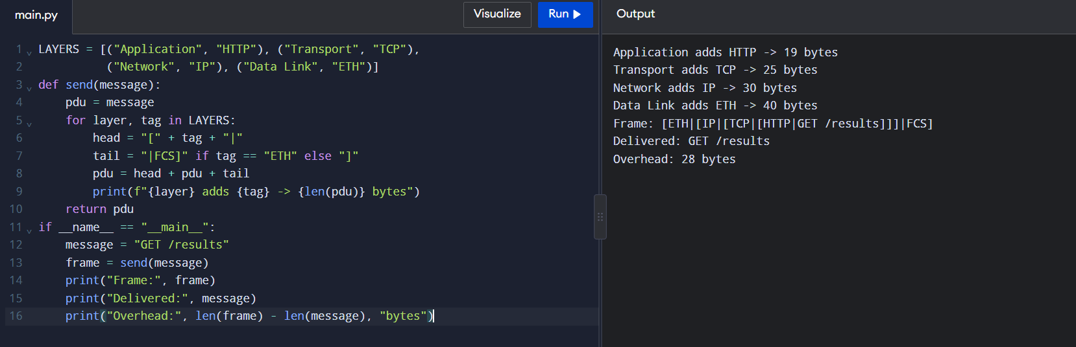

Task 4 – Choose a Medium for Each Run (There Is a Trap)
Run | Distance | Medium | Deciding reason
(a) Robot cell next to arc welders | 85 m | Cat6A S/FTP (fibre if noise persists) | within 100 m, but welding EMI – shielding and balanced pairs keep the SNR high
(b) Office floor → shop-floor switch | 140 m | Multimode fibre (OM3/OM4) | > 100 m copper limit (90 m link + 10 m patch); fibre also isolates electrical noise
(c) Shop floor → data centre | 550 m | Single-mode fibre | 1000BASE-SX multimode reaches exactly 550 m with no margin and falls to 300–400 m at 10 Gbps; the plant needs 1.27 Gbps (Task 1)
(d) Plant → head office | 400 km | Leased line / carrier single-mode fibre (DWDM with amplifiers) | far beyond any copper or unamplified fibre limit (~80–100 km)
The trap: run (b) looks like normal office cabling but at 140 m it is already past the 100 m Ethernet copper limit – ordinary Cat6 would fail. Runs (c) and (d) cannot use copper Ethernet at all; (d) is impossible by any copper method.
Shannon capacity, C = B × log2(1 + SNR), B = 250 MHz
- SNR 40 dB → ratio 10,000 → C = 250 × 10^6 × log2(10,001) = 250 × 10^6 × 13.288 = 3,322 Mbps
- SNR 15 dB → ratio 31.62 → C = 250 × 10^6 × log2(32.62) = 250 × 10^6 × 5.028 = 1,257 Mbps
Noise near the welders cuts the theoretical capacity by 62 %. A robot command needs only 0.8 Mbps, so capacity is not the issue; the real damage is that at low SNR the bit-error rate rises, frames fail the CRC and are retransmitted or lost, so delay and jitter break the 10 ms deadline. That is why the robot cell needs shielded cable (or fibre).
Why measured speed is below Shannon: real modulation/coding schemes cannot reach the limit; headers, preamble and inter-frame gaps use bandwidth; noise is not purely Gaussian (crosstalk, impulse noise from welders); attenuation and retransmissions reduce goodput; hardware must work in finite time.
Complete the Code – TODO 1 and TODO 2
def nyquist(bandwidth_hz, levels):
return 2 * bandwidth_hz * math.log2(levels)
def shannon(bandwidth_hz, snr_db):
snr = 10 ** (snr_db / 10)
return bandwidth_hz * math.log2(1 + snr)
Expected output reproduced: telephone line 0.03 Mbps, Cat6 pair 3321.96 Mbps, Wi-Fi 6 channel ≈ 1329.5 Mbps, Nyquist 12.4 kbps.
SNR for 56 kbps on 3,100 Hz: 56,000 / 3,100 = 18.06 bits/Hz → SNR = 2^18.06 − 1 ≈ 274,000 → 10 × log10(274,000) ≈ 54.4 dB. Real telephone lines give about 30–40 dB, so this is not realistic on an analogue line; 56k modems worked only because the downstream path was digital, and they typically reached about 53 kbps.
Alternative concept – Wi-Fi 6 in the robot cell: C = 160 × 10^6 × log2(1 + 31.62) = 160 × 10^6 × 5.028 ≈ 804 Mbps. Capacity is ample, but a wireless link is not acceptable for hard 10 ms commands: CSMA/CA contention, retries, interference from welding and metal reflections make delay non-deterministic, and there is no guarantee for the worst case. Keep shielded cable for fixed robots; Wi-Fi only for non-critical use.

Runnable Python example – Task 4
import math
def nyquist(bandwidth_hz, levels):
return 2 * bandwidth_hz * math.log2(levels)
def shannon(bandwidth_hz, snr_db):
snr = 10 ** (snr_db / 10)
return bandwidth_hz * math.log2(1 + snr)
for snr_db in (40, 15):
print(f"Shannon capacity at {snr_db} dB: {shannon(250e6, snr_db)/1e6:.2f} Mbps")
required_snr = 2 ** (56000 / 3100) - 1
print(f"SNR for 56 kbps over 3100 Hz: {10*math.log10(required_snr):.2f} dB")
print(f"Nyquist at 3100 Hz, 16 levels: {nyquist(3100,16)/1000:.2f} kbps")

OUTPUT SCREENSHOT – TASK 4
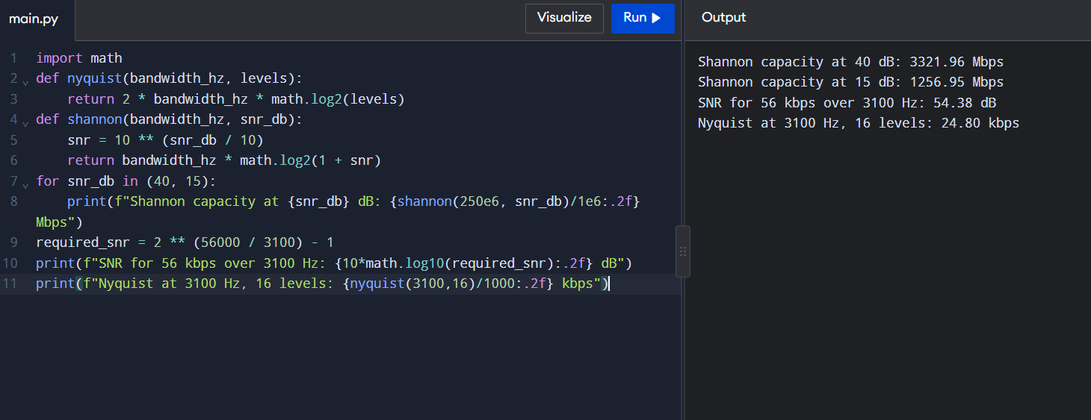

Task 5 – Wi-Fi 6 or 5G for Moving Equipment?
Trip time = 1,200 m / 2 m/s = 600 s.
 | Wi-Fi | Private 5G
Cell size | 30 m | 300 m
Cells along 1.2 km | 1,200 / 30 = 40 | 1,200 / 300 = 4
Hand-overs per trip | 39 (about 40) | 3 (about 4)
Time per hand-over | 150 ms | 20 ms
Unreachable time per trip | 39 × 150 ms = 5.85 s (0.98 % of the trip) | 3 × 20 ms = 60 ms
Distance travelled unreachable | 2 m/s × 5.85 s = 11.7 m | 12 cm
10 ms commands missed per trip | 39 × 15 = 585 | 3 × 2 = 6
Even 5G's 20 ms exceeds the 10 ms deadline, so it needs make-before-break mobility, dual connectivity or packet duplication to be perfect.
5G service type per traffic
Traffic | Service type | Reason
AGVs (and robot commands) | URLLC | 10 ms deadline, very high reliability
CCTV cameras | eMBB | 96 Mbps per line, high throughput
Sensors | mMTC | many devices, tiny packets, low power
Better choices than Wi-Fi/5G: Bluetooth (BLE) for short-range personal devices – handheld scanners, tool tags, wearables; Zigbee for low-power mesh of battery sensors within tens of metres (lighting, environment); LoRa for long-range, very-low-rate sensors – distant tanks, yards, outbuildings – with multi-year batteries.
Wi-Fi 6 with 802.11r? Fast BSS transition cuts the hand-over from about 150 ms to roughly 20–50 ms, but that is still above 10 ms, so each of the 39 hand-overs still misses 2–5 commands (about 80–195 per trip). It might meet the deadline on a quiet channel but cannot guarantee it. Remaining risks: client-driven roaming decisions, scanning delay, CSMA/CA contention and retries, welding interference and multipath, and no latency bound.
Alternative concept – LoRaWAN for 600 sensors: demand = 600 × 50 B × 8 = 240,000 bps = 240 kbps versus about 5 kbps per gateway → 48× over capacity. One gateway could serve only 5,000 / 400 = 12 sensors at 50 B/s. It would fit only if reporting slows: 50 B every 60 s = 6.7 bps per sensor → about 750 sensors per gateway. Decision: slow temperature sensors on LoRa; vibration sensors (50 B/s) stay on Wi-Fi/5G mMTC or wired.

Runnable Python example – Task 5
import math
distance_m, speed_mps = 1200, 2
trip_s = distance_m / speed_mps
handover_count = 39
print("AGV trip time:", trip_s, "seconds")
print("Wi-Fi interruption:", handover_count * 0.150, "seconds")
print("Private 5G interruption:", handover_count * 0.020, "seconds")
print("600-sensor LoRaWAN demand:", 600 * 50 * 8 / 1000, "kbps")
print("Gateways needed at 5 kbps each:", math.ceil(600 * 50 * 8 / 5000))

OUTPUT SCREENSHOT – TASK 5
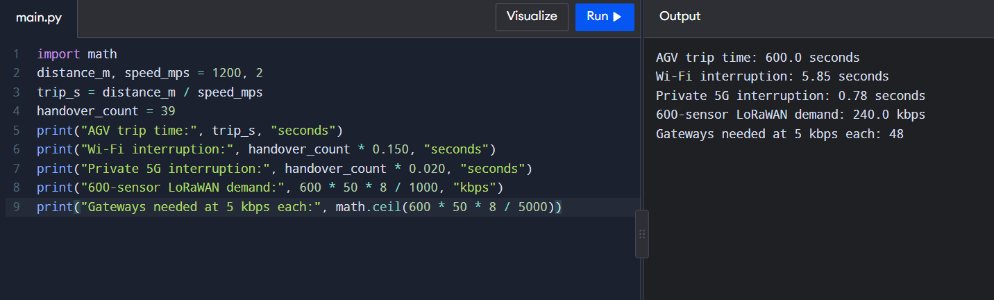

Task 6 – Interpret an Ethernet Port Report
Meaning of the counters
- Late collision (412): a collision detected after the first 512 bits (64 bytes, the slot time) of a frame. Legal collisions occur early; a late one means the other end transmitted without waiting – typically a duplex mismatch – or the cable/repeater chain is too long.
- CRC error (1,907): the received frame's FCS does not match, so the frame was corrupted or truncated and is dropped. Together with 2,381 rx_errors this is the signature of a duplex mismatch: the half-duplex end follows CSMA/CD, while the full-duplex end sends whenever it likes and ignores collisions, producing truncated frames and late collisions on the half-duplex side.
Likely cause and fix: the PC is forced to 100 Mb/s half duplex with auto-negotiation off, while the gigabit switch port is not operating half duplex. Check the switch's real state (show interfaces status). The standard says an auto-negotiating side falls back to half duplex when it hears no negotiation, so the mismatch appears whenever the switch port was set or ended up full duplex.
Linux:
sudo ethtool -s eth0 autoneg on # preferred: re-enable auto-negotiation
# or force both ends identically: speed 100 duplex full autoneg off (switch port must match)
ethtool eth0 # verify: Duplex: Full, Auto-negotiation: on
Windows: Device Manager → network adapter → Properties → Advanced → Speed & Duplex = Auto Negotiation, or in PowerShell Set-NetAdapterAdvancedProperty -Name 'Ethernet' -DisplayName 'Speed & Duplex' -DisplayValue 'Auto Negotiation'. Gigabit Ethernet requires auto-negotiation. Clear counters and re-check: errors should stop increasing.
Addressing
- 01:00:5e:0a:01:02 – the least-significant bit of the first byte (0x01) is 1, so it is a group (multicast) address, not a single device. The prefix 01:00:5e is IPv4 multicast; the low 23 bits map to 224.10.1.2 (one of 32 IP groups sharing it).
- 3c:52:82:4e:11:07 – the first three bytes 3c:52:82 are the OUI, identifying the interface's manufacturer (look it up in the IEEE OUI registry). It is a unicast, globally administered address.
Jumbo frames (9,000 bytes) for the CCTV storage server: they help moderately. With 58 bytes of header per frame, overhead falls from 58/1,518 = 3.8 % to 58/9,018 = 0.64 %, and packets per second fall about 6× (96 Mbps: about 8,200 pps → 1,340 pps), reducing CPU and interrupts on the server. What must also change: every NIC, switch port and router interface on the path must be set to the same larger MTU (about 9,000 / frame 9,216); otherwise frames are dropped or fragmented. Keep jumbo frames on a separate storage VLAN so 72 µs serialisation per frame and larger retransmissions never touch robot traffic, and cameras must actually send large packets.
Alternative concept – ring vs star of industrial switches (one cable cut)
 | Ring with fast recovery (MRP) | Star
Recovery time | about 200 ms (RSTP 1–2 s; HSR/PRP 0 ms) | none – no alternative path; down until repaired
Who loses connection | all devices briefly during reconvergence, none afterwards | only the switch(es) and devices behind the cut cable
Impact on robots | 200 ms = 100 missed 2 ms commands, so critical cells need HSR/PRP | all robots behind the cut stop until repair
A ring costs less cabling and survives one cut; a star is simpler and contains faults, and becomes resilient with dual uplinks.

Runnable Python example – Task 6
multicast = (int("01", 16) & 1) == 1
print("01:00:5e:0a:01:02 is", "multicast" if multicast else "unicast")
print("OUI for 3c:52:82:4e:11:07 is 3c:52:82")
print("Jumbo frames require compatible MTU settings on every device in the storage path.")

OUTPUT SCREENSHOT – TASK 6
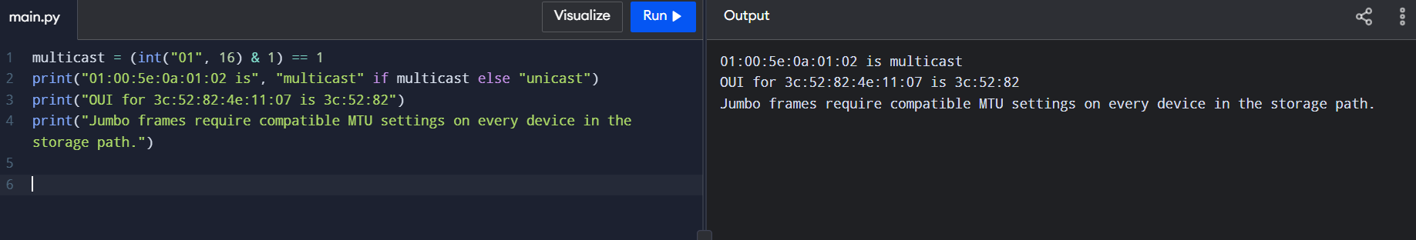

Task 7 – Will the Receiver Notice the Error?
CRC by hand. Data 1101011011, generator 1011 (x³ + x + 1), so r = 3. Append three zeros: dividend = 1101011011000. Modulo-2 division (leading bit 1 → XOR with 1011; leading bit 0 → XOR with 0000):
Step | Working value | Divisor used | Result (remainder carried)
1 | 1101 | 1011 | 0110 → 110
2 | 1100 (bring down 0) | 1011 | 0111 → 111
3 | 1111 (bring down 1) | 1011 | 0100 → 100
4 | 1001 (bring down 1) | 1011 | 0010 → 010
5 | 0100 (bring down 0) | 0000 | 0100 → 100
6 | 1001 (bring down 1) | 1011 | 0010 → 010
7 | 0101 (bring down 1) | 0000 | 0101 → 101
8 | 1010 (bring down 0) | 1011 | 0001 → 001
9 | 0010 (bring down 0) | 0000 | 0010 → 010
10 | 0100 (bring down 0) | 0000 | 0100 → 100
CRC = 100, transmitted frame = 1101011011100 (matches the program).
Is 1101011011101 accepted? It is the transmitted frame with the last bit flipped. Dividing the received frame by 1011 (steps 1–7 as above, then 1011 ⊕ 1011 = 0000, then 0000, then 0001) leaves remainder 001 ≠ 000, so the frame is rejected.
Burst and undetectable errors
- Any burst of length ≤ r = 3 bits is always detected. A 4-bit burst is detected with probability 1 − 2^-(r−1) = 75 %, longer bursts with 1 − 2^-r = 87.5 %.
- An error pattern is undetectable when it is a multiple of the generator. Example: flipping bits with pattern 0000000001011 (the generator itself) – the remainder stays 0. Also two flipped bits 7 positions apart (pattern 1000 0001), because x⁷ + 1 is divisible by x³ + x + 1.
Two-dimensional even parity (4 × 4 block of my choice)
 | c1 | c2 | c3 | c4 | row parity
r1 | 1 | 0 | 1 | 1 | 1
r2 | 0 | 1 | 0 | 0 | 1
r3 | 1 | 1 | 0 | 0 | 0
r4 | 0 | 0 | 1 | 1 | 0
column parity | 0 | 0 | 0 | 0 | 0
Undetected 4-bit pattern: flip the four corners of a rectangle – r1c1, r1c2, r3c1, r3c2. Rows 1 and 3 and columns 1 and 2 each change by two bits, so every parity is still even and the error is missed.
Internet checksum of 4500, 0073, 0000, 4000 (hex): 4500 + 0073 = 4573; + 0000 = 4573; + 4000 = 8573 (no carry to fold). One's complement = FFFF − 8573 = 7A8C. Check at the receiver: 8573 + 7A8C = FFFF, so the data passes.
Complete the Code – TODO 1
if rem[i] == '1':
for j in range(len(divisor)):
rem[i + j] = '0' if rem[i + j] == divisor[j] else '1'
Expected output reproduced: transmitted: 1101011011100, no error : True, 1-bit error: False, 3-bit burst: False.
Find an undetected pattern with the program (add at the end):
for e in range(1, 2 ** len(frame)):
pattern = format(e, '0' + str(len(frame)) + 'b')
bad = ''.join('1' if a != b else '0' for a, b in zip(frame, pattern))
if check(bad, GEN):
print('undetected error pattern:', pattern)
break
It prints 0000000001011. Reason: that error polynomial equals the generator, so the corrupted frame is still exactly divisible by 1011.
Alternative concept – even parity bit vs CRC-3 (1011) (13-bit frame)
Method | 2-bit pattern | Result | 4-bit pattern | Result
Even parity | 0000000000011 | missed (even number of flips) | 0000000001111 | missed
CRC-3 (1011) | 0000010000001 (7 apart) | missed | 0000000011101 (multiple of 1011) | missed
CRC-3 (1011) | 0000000000011 (adjacent) | detected (remainder 011) | 0000000001111 | detected (remainder 100)
Parity catches what CRC-3 misses only for odd-weight multiples of the generator, e.g. the 3-bit pattern 1011. Parity misses every even-weight error, including all double errors and 4-bit bursts, which CRC-3 catches unless they are multiples of 1011. CRC is far stronger overall (all 1-bit, all bursts ≤ 3, all 2-bit errors less than 7 apart) for 3 check bits versus 1.

Runnable Python example – Task 7
def mod2_division(dividend, divisor):
bits = list(map(int, dividend))
div = list(map(int, divisor))
for i in range(len(bits) - len(div) + 1):
if bits[i]:
for j in range(len(div)):
bits[i+j] ^= div[j]
return "".join(map(str, bits[-(len(div)-1):]))
data, generator = "1101011011", "1011"
remainder = mod2_division(data + "0" * (len(generator)-1), generator)
print("Data:", data)
print("Generator:", generator)
print("CRC remainder:", remainder)
print("Transmitted codeword:", data + remainder)

OUTPUT SCREENSHOT – TASK 7
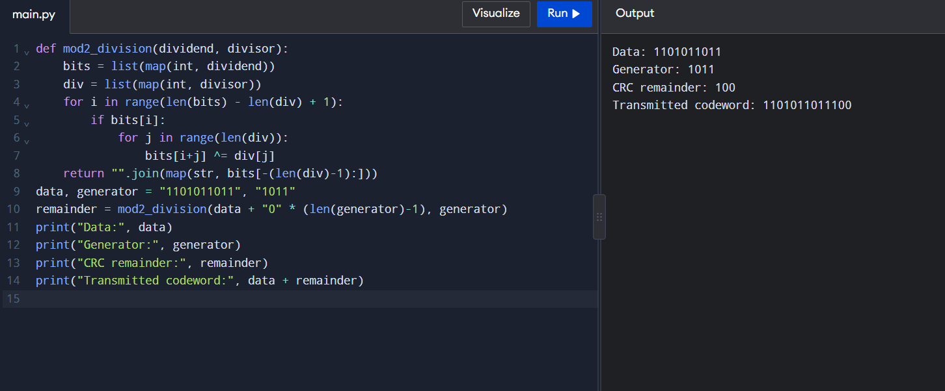

Task 8 – Correct the Error or Ask Again?
Check bits for a 16-bit word: need 2^r ≥ m + r + 1. r = 4: 16 ≥ 21? No. r = 5: 32 ≥ 22? Yes → r = 5, codeword = 21 bits, overhead = 5/16 = 31.25 % of the data (23.8 % of the codeword).
Minimum Hamming distance of {00000, 01011, 10101, 11110}: pairwise distances – 00000/01011 = 3, 00000/10101 = 3, 00000/11110 = 4, 01011/10101 = 4, 01011/11110 = 3, 10101/11110 = 3. d_min = 3. It detects d − 1 = 2 errors and corrects ⌊(d − 1)/2⌋ = 1 error.
Hamming(7,4), received 0110111 (positions 1–7 = 0 1 1 0 1 1 1):
- s1 (positions 1, 3, 5, 7) = 0 ⊕ 1 ⊕ 1 ⊕ 1 = 1
- s2 (positions 2, 3, 6, 7) = 1 ⊕ 1 ⊕ 1 ⊕ 1 = 0
- s3 (positions 4, 5, 6, 7) = 0 ⊕ 1 ⊕ 1 ⊕ 1 = 1
- error position = 1 + 2 × 0 + 4 × 1 = 5. Flip bit 5 → corrected codeword 0110011, data bits (positions 3, 5, 6, 7) = 1011.
FEC or ARQ? Retransmission costs 40 ms – four times the 10 ms control deadline – and on a noisy radio link retransmissions themselves can fail. FEC adds a fixed 31 % of bits but gives a constant, short delay. For a time-critical or noisy radio link choose FEC (or hybrid FEC + CRC). Video streaming and 5G use FEC because late retransmitted data is useless for live video (a frame is due every ~33 ms), because one transmitter serves many receivers, and because radio error rates are high (5G uses LDPC/Polar codes plus HARQ to meet 1–4 ms latency).
Complete the Code – TODO 1
def decode(c):
s1 = c[0] ^ c[2] ^ c[4] ^ c[6]
s2 = c[1] ^ c[2] ^ c[5] ^ c[6]
s3 = c[3] ^ c[4] ^ c[5] ^ c[6]
pos = s1 + 2 * s2 + 4 * s3
c = c[:]
if pos:
c[pos - 1] ^= 1
return pos, [c[2], c[4], c[5], c[6]]
Output: codeword : 0110011, error at None: syndrome 0, data 1011, error at 5 : syndrome 5, data 1011.
Two flipped bits fool the decoder: flip positions 1 and 2 (rx[0] ^= 1; rx[1] ^= 1). Received 1010011 gives s1 = 1, s2 = 1, s3 = 0 → syndrome 3, so the decoder flips bit 3 – a correct bit – and returns data 0011 instead of 1011. Hamming(7,4) (d_min = 3) corrects one error but miscorrects two.
Alternative concept – BER = 10⁻³, 16-bit reading, 40 ms retransmission (detection overhead ignored)
 | Hamming FEC (21,16) | Detect + ARQ (16 bits)
Bits per attempt | 21 | 16
P(reading fails) | P(≥ 2 errors in 21 bits) = 1 − 0.999²¹ − 21(0.001)(0.999²⁰) = 0.021 % | 1 − 0.999¹⁶ = 1.59 %
Average bits per reading | 21 × 1.0002 ≈ 21.0 | 16 / 0.984 = 16.26
Average extra delay | 0.00021 × 40 ms = 0.008 ms | (0.0159 / 0.984) × 40 ms = 0.65 ms
Worst case | 40 ms once in about 4,800 readings | 40 ms once in about 63 readings
ARQ uses 23 % fewer bits, FEC has 80× lower mean delay and almost no delay spikes. Decision: for 1-reading-per-second trending, ARQ is acceptable; for vibration alarms or anything near the 10 ms deadline, use FEC.

Runnable Python example – Task 8
def hamming74_decode(bits):
b = [0] + [int(x) for x in bits]
s1 = b[1] ^ b[3] ^ b[5] ^ b[7]
s2 = b[2] ^ b[3] ^ b[6] ^ b[7]
s4 = b[4] ^ b[5] ^ b[6] ^ b[7]
syndrome = s1 + 2*s2 + 4*s4
corrected = b[:]
if syndrome:
corrected[syndrome] ^= 1
return syndrome, "".join(map(str, corrected[1:])), "".join(str(corrected[i]) for i in (3,5,6,7))
received = "0110111"
syndrome, corrected, data = hamming74_decode(received)
print("Received:", received)
print("Error position (0 means none):", syndrome)
print("Corrected codeword:", corrected)
print("Decoded data:", data)
print("For 16 data bits, r=5 check bits are needed; total length = 21 bits.")

OUTPUT SCREENSHOT – TASK 8
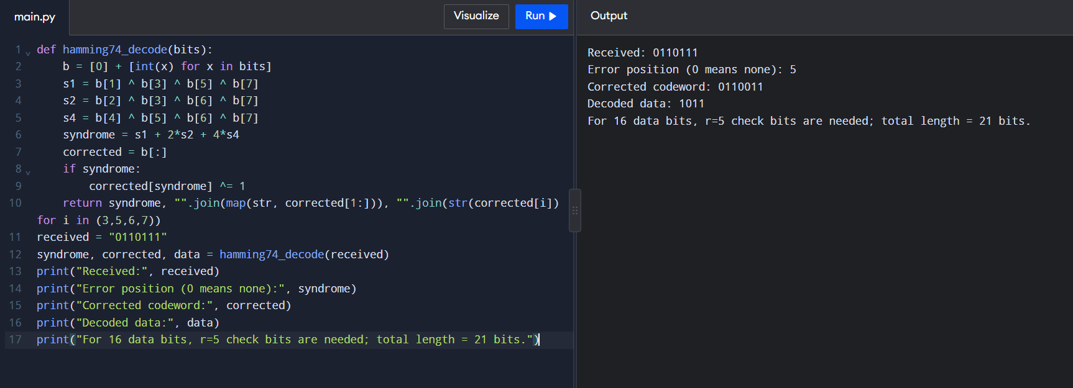

Task 9 – How Big Must the Window Be?
Frame = 1,500 B = 12,000 bits; 400 km at 2 × 10⁸ m/s; 1 Gbps.
- Transmission time = 12,000 / 10⁹ = 12 µs
- Propagation time = 400,000 / (2 × 10⁸) = 2 ms = 2,000 µs
- a = prop / tx = 2,000 / 12 = 166.67
- Stop-and-wait utilisation = 1 / (1 + 2a) = 1 / 334.33 = 0.299 % → throughput ≈ 0.00299 × 1,000 Mbps = 2.99 Mbps (one 12,000-bit frame per 4.012 ms round trip). The fibre is wasted.
- Smallest window W = 1 + 2a = 334.33 → 335 frames (≈ 502 KB, equal to the bandwidth-delay product 1 Gbps × 4 ms = 4 Mbit).
- Sequence-number bits: Go-Back-N needs window ≤ 2^k − 1 → 2^k ≥ 336 → k = 9 bits. Selective Repeat needs window ≤ 2^(k−1) → 2^k ≥ 670 → k = 10 bits.
- After one loss: Selective Repeat resends only 1 frame; Go-Back-N resends the lost frame and every frame sent after it, up to 335 frames (about 0.5 MB). The cost for Selective Repeat is receiver memory and logic: it must buffer out-of-order frames (up to 335 × 1,500 B = 502.5 KB) and the sender needs a timer per frame; a Go-Back-N receiver needs one frame buffer.
- Frame delimiting: HDLC and PPP start and end each frame with the flag byte 01111110 (0x7E). HDLC uses bit stuffing (the sender inserts a 0 after five consecutive 1s, the receiver removes it); PPP uses byte stuffing (a 0x7E inside data becomes 0x7D 0x5E, i.e. an escape byte 0x7D and the byte XOR 0x20).
Complete the Code – TODO 1
a = prop / tx
u = min(1.0, window / (1 + 2 * a))
return u, a
Output reproduced: campus LAN a = 0.08 (85.7 %, 100 %, 100 %); city fibre a = 20.83 (2.3 %, 16.4 %, 100 %); satellite a = 150.00 (0.3 %, 2.3 %, 42.2 %).
Satellite link, 100 % utilisation: W = 1 + 2a = 1 + 300 = 301 frames (Go-Back-N 9 bits, Selective Repeat 10 bits).
Alternative concept – Selective Repeat with window 64 on the head-office link
- Utilisation = 64 / 334.33 = 19.1 %
- Throughput = 0.191 × 1 Gbps = 191 Mbps (the 335-frame window gives 1,000 Mbps)
- Receiver buffer = 64 × 1,500 B = 96 KB (versus 502.5 KB); sequence numbers need 2^k ≥ 128 → 7 bits
Window 64 saves memory but wastes 81 % of the link; the 335-frame window is needed. Choose Selective Repeat (as TCP SACK does) with window scaling, because Go-Back-N would resend up to 335 frames after every loss on a long link.

Runnable Python example – Task 9
import math
def utilisation(window, frame_bytes, rate_bps, distance_m):
tx = frame_bytes * 8 / rate_bps
prop = distance_m / 2e8
a = prop / tx
return tx, prop, a, min(1.0, window / (1 + 2*a))
tx, prop, a, u = utilisation(1, 1500, 1e9, 400_000)
print(f"Transmission time: {tx*1e6:.2f} microseconds")
print(f"One-way propagation: {prop*1e3:.2f} ms")
print(f"a = {a:.2f}")
print(f"Stop-and-wait utilisation: {u*100:.3f}%")
print("Window for full utilisation:", math.ceil(1 + 2*a), "frames")

OUTPUT SCREENSHOT – TASK 9
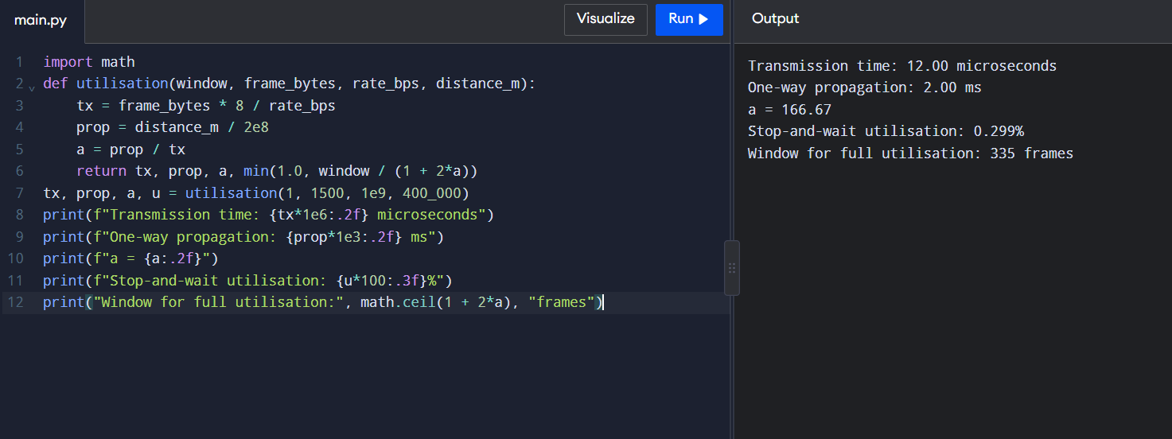

Task 10 – Find Where the Delay Comes From (4 marks)
Propagation check. 400 km / (2 × 10⁸ m/s) = 2 ms one way, 4 ms round trip. Traceroute times are round-trip, and the last hop shows 12.6 ms, so propagation explains 4 / 12.6 = 31.7 %. The other ~8.6 ms is queueing, router processing at five hops, serialisation and a fibre route longer than the straight 400 km (real paths are typically 1.3–1.5× longer, which alone would give 5–6 ms).
Hop 3 shows one 38.2 ms value (others 4.0 and 4.2 ms): a single transient – the router generates the ICMP reply on its slow control-plane CPU, or briefly queued it behind other work. It is not a fault: hops 4 and 6 (11.8 and 12.6 ms) do not carry the extra 34 ms, so real forwarding was not delayed. Watch it only if it repeats.
Hop 5 shows only stars: that router is configured (or rate-limited by a firewall) not to answer TTL-expired probes, but it forwards traffic – hop 6 answers through it. Not a fault.
Which hop adds the most delay
Hop | Address | Typical RTT | Added by this hop
1 | 10.10.1.1 | 0.6 ms | 0.6 ms
2 | 100.64.0.1 (ISP carrier-grade NAT range) | 3.1 ms | 2.5 ms
3 | 172.31.4.9 | 4.0 ms | 0.9 ms
4 | 103.21.8.17 | 11.8 ms | 7.8 ms (largest)
5 | hidden | – | –
6 | 10.200.0.10 (head office, private) | 12.6 ms | 0.8 ms
Hop 4 is the long-haul segment between the ISP and the carrier, containing most of the ~4 ms propagation plus queueing.
[YOUR EVIDENCE] – your own measurement. Run these against a real server and commit the outputs and screenshots to Task10/:
Windows: tracert -d <server> ping -n 20 <server>
Linux: traceroute -n <server> ping -c 20 <server>
In Wireshark capture on your active interface, filter icmp for the ping and tcp.port == 80 || tcp.port == 443 for a web request, then annotate one packet:
Layer | Fields to mark on your screenshot
Ethernet II (L2) | destination MAC, source MAC, EtherType (0x0800)
IPv4 (L3) | source IP, destination IP, TTL, protocol (1 = ICMP, 6 = TCP)
TCP / ICMP (L4) | ports, sequence/ack, flags (TCP) or type/code (ICMP)
Application (L5–7) | HTTP/TLS data or ICMP payload
Compare your min/avg/max ping time with the propagation delay for the distance to your server.
Alternative concept – SNMP counters and NetFlow vs occasional ping/traceroute
Problem in the traceroute | Ping/traceroute | SNMP counters | NetFlow records
Hop 3 one-off 38 ms spike | caught only if a test runs at that instant | likely averaged away (polling every 1–5 min) | not visible
Hop 4 large delay (7.8 ms) | shows it when run, no cause | shows utilisation, queue drops and errors on the interface within one poll interval | shows which flows are filling the link (e.g. CCTV vs robot traffic)
Hop 5 stars | only traceroute reveals it (and it is harmless) | not relevant | not relevant
Continuous monitoring detects sustained congestion within minutes and explains the cause; occasional tests find path and reachability problems but miss intermittent ones. Use both, plus active probes (IP SLA) for latency.

Runnable Python example – Task 10
# Run these commands in your own terminal and paste actual output screenshots.
# Windows: tracert -d 8.8.8.8
# ping -n 20 8.8.8.8
# Linux/macOS: traceroute -n 8.8.8.8
# ping -c 20 8.8.8.8
# Wireshark display filters: icmp
# tcp.port == 80 || tcp.port == 443
print("400 km fibre: 2 ms one-way propagation and about 4 ms round-trip propagation.")
print("Traceroute stars may mean a router does not answer probes, even if it forwards traffic.")

OUTPUT SCREENSHOT – TASK 10
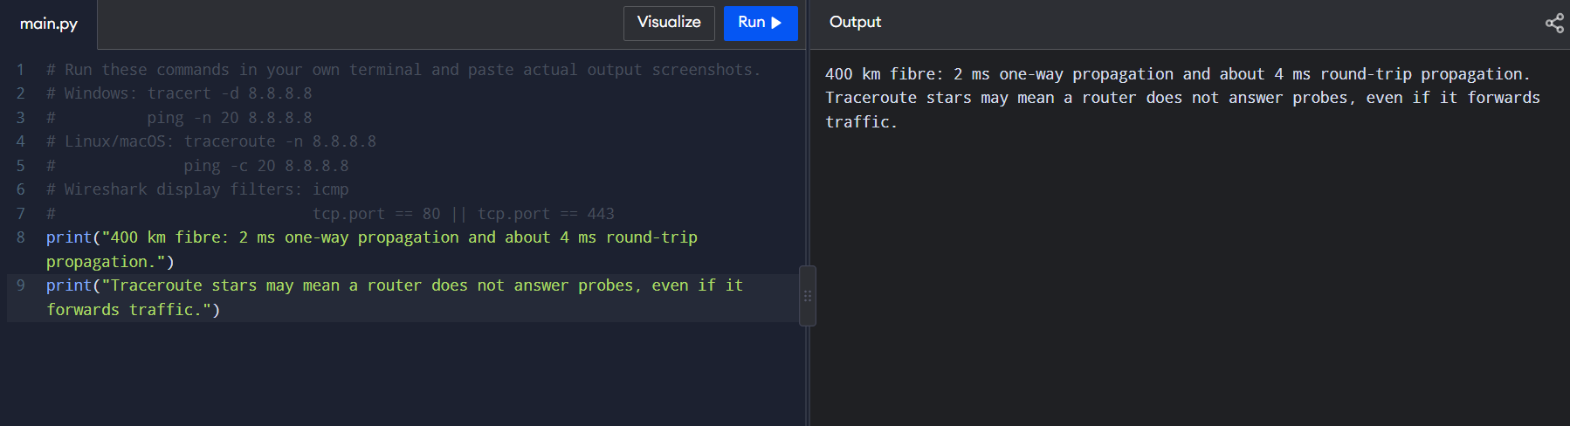

Task 11 – Defend the Network Design
Recommended design (numbers from Tasks 1–10)
Area | Medium | Wireless | Ethernet settings | Error / flow control and justification
Robot cells near welders | Cat6A S/FTP, 85 m (Task 4; fibre if EMI persists) | none | 1000BASE-T, full duplex, auto-negotiation ON (Task 6), own VLAN, strict-priority 802.1p, MTU 1500 | CRC-32 detect-and-drop plus real-time (UDP/industrial Ethernet) – no retransmission, because a 2 ms-period command is stale after 40 ms (Task 8). a = 0.425 µs / 2.06 µs = 0.2, window 2 is enough (Task 9 formula)
AGVs / mobile equipment | – | private 5G URLLC (Task 5) | – | 5G HARQ + LDPC/Polar FEC; 3 hand-overs, 60 ms dark per trip, versus 39 and 5.85 s on Wi-Fi
Office, ERP, IP phones | Cat6 ≤ 100 m; fibre for the 140 m run | Wi-Fi 6 | full duplex, voice VLAN | 802.11 per-frame ACK / block-ack + TCP; 30 Mbps per line (Task 1)
Sensors | – | slow temperature on LoRa (about 750 per gateway at 1/min); vibration (0.24 Mbps) on Wi-Fi 6 / 5G mMTC | – | Hamming FEC when noisy: 21 bits and 0.008 ms average extra delay vs 0.65 ms for ARQ (Task 8)
CCTV and storage | 10G fibre | – | jumbo frames (MTU 9,000) on a separate storage VLAN only | motion-triggered recording: 4.8 Mbps per line, 536 Mbps plant (Task 1); TCP
Shop floor → data centre | single-mode fibre, 550 m, 10 Gbps (plant needs 1.27 Gbps) | – | redundant ring (MRP, ~200 ms) or dual uplinks | CRC-32; no L2 ARQ
Plant → head office | leased line / carrier fibre, 400 km | – | 1 Gbps minimum, 2 Gbps preferred | a = 166.7; stop-and-wait gives only 2.99 Mbps; Selective Repeat (TCP SACK) with window ≥ 335 frames (~502 KB) and 10-bit sequence numbers
Two biggest remaining risks
- Single point of failure and capacity on the head-office link: one 400 km circuit carries everything; if it fails the ERP link is down, and without motion-triggered CCTV the plant load is 1.27 Gbps (> 1 Gbps). Mitigation: second diverse path, 10 Gbps, and keep CCTV local.
- Wireless determinism for moving equipment: 5G's 20 ms hand-over is still above the 10 ms deadline (6 missed commands per trip), and a ring failure takes ~200 ms = 100 missed robot commands. Mitigation: make-before-break/dual connectivity, PRP/HSR for critical cells, and an AGV watchdog that stops after 3 missed commands (30 ms = 6 cm at 2 m/s).
Does it work for five plants? Yes, with scaling changes. Motion-triggered traffic is 5 × 536.32 = 2.68 Gbps across the group, so plant and head-office uplinks need 10 Gbps. If clips, office and sensors all went to the head office: 8 × (0.24 + 4.8 + 30) = 280 Mbps per plant, 1.40 Gbps for five (> 1 Gbps), so 10 Gbps aggregation at the head office. 1,500 devices per plant need VLANs per line (40 devices, /26) with routing, not one broadcast domain. Window size must follow distance: a plant 1,000 km away has a = 416.7 and needs W = 835 frames.
Alternative concept – everything on private 5G instead of a wired backbone with Wi-Fi (assumption: one 100 MHz TDD cell gives about 600 Mbps downlink and 100–150 Mbps uplink)
Traffic (plant of 8 lines) | Volume | Carry on
Robot commands (URLLC) | 256 Mbps (mostly downlink) | 5G (or cable for fixed cells)
Sensors (mMTC) | 1.9 Mbps | 5G
AGV commands | 12 Mbps | 5G
Continuous CCTV | 768 Mbps uplink | cable – exceeds cell uplink
Office / ERP | 240 Mbps | cable + Wi-Fi 6
Backbone, storage, head-office link | 1.27 Gbps | fibre
5G carries only about 258 Mbps (20 %) of the 1,265.92 Mbps plant load – the delay-critical, mobile and massive-device part – while the high-volume, fixed, uplink-heavy traffic stays on cable, where it is cheaper per bit and cannot disturb the URLLC slice. A pure-5G plant is therefore not recommended.

Runnable Python example – Task 11
design = {
"Robot cells": "Cat6A S/FTP, full duplex, VLAN and strict priority",
"AGVs": "Private 5G URLLC with make-before-break / packet duplication",
"Office and phones": "Wi-Fi 6 or wired Ethernet; voice VLAN",
"Vibration sensors": "Wired, Wi-Fi 6 or 5G mMTC by location",
"CCTV": "Local motion-triggered recording; separate storage VLAN; 10G fibre",
"Head-office link": "1–2 Gbps plus a diverse backup path",
}
for area, recommendation in design.items():
print(f"{area}: {recommendation}")
print("Five-plant motion-triggered estimate:", 5 * 536.32, "Mbps")

OUTPUT SCREENSHOT – TASK 11
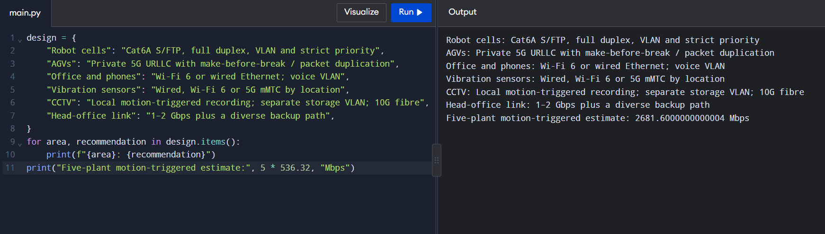

Task 12 – Day-4 Design Challenge: Re-evaluate and Adapt the Design
Decision: MODIFY the wired and office design; REDESIGN the wireless layer for moving equipment.

A. Impact Analysis (2 marks)
Area | Affected? | Impact
Media | Yes | the 5G radio units need fibre backhaul and an on-site 5G core in the data centre (550 m single-mode run); 4 cells of 300 m cover the 1.2 km route (5 with overlap)
Wireless choice | Yes | Wi-Fi 6 no longer serves AGVs (Task 5); Wi-Fi 6 stays for offices; sensors on LoRa/mMTC
Error control | Yes | AGV link uses 5G HARQ/FEC with an application watchdog, not 40 ms ARQ
Backbone Ethernet | Yes | load increases above 1 Gbps; QoS slices and priority needed
Traffic recalculation. Assumed per AGV: 200 B command every 10 ms (0.16 Mbps) + 100 B status every 10 ms (0.08 Mbps) + one 4 Mbps camera = 4.24 Mbps. 50 AGVs = 212 Mbps (commands and status alone: 12 Mbps).
Case | Traffic
Task 1 plant, continuous CCTV | 1,265.92 Mbps
+ 50 AGVs | 1,477.92 Mbps (+16.7 %, 148 % of 1 Gbps)
Motion-triggered CCTV + 50 AGVs | 536.32 + 212 = 748.32 Mbps (74.8 %)
Devices | 1,500 + 50 = 1,550

B. Test the Original Design (2 marks)
The original used Wi-Fi 6 with APs every 30 m. Per Task 5, per AGV trip (600 s):
Original design with 50 AGVs | Result
Hand-overs per AGV | 39
Unreachable time per AGV | 39 × 150 ms = 5.85 s (11.7 m travelled out of contact, 0.3 m per hand-over)
Missed 10 ms commands per AGV | 39 × 15 = 585
Missed across 50 AGVs | 29,250 per trip cycle ≈ 49 per second plant-wide
Hand-overs plant-wide | 50 × 39 / 600 = 3.25 per second
With 802.11r (assume 50 ms) | 195 missed per AGV, 9,750 for 50 – still not zero
The requirement is that AGVs must never miss a command, so the original design fails; contention among 50 AGVs and 150 office users on shared channels, and welding noise (SNR 15 dB), make it worse.

C. Adaptation or Redesign (2 marks)
- Private 5G, URLLC slice for AGV and mobile-robot commands, eMBB slice for AGV and fixed cameras, mMTC slice for vibration sensors; on-site 5G core (local breakout) so traffic never leaves the plant.
- 5 gNBs along the AGV route with overlapping cells; make-before-break / dual connectivity and packet duplication so hand-over interruption is ~0 ms.
- Wi-Fi 6 for offices, handhelds and IP phones only.
- Fibre backbone upgraded to 10 Gbps single-mode (550 m to data centre) in a redundant ring; Cat6A S/FTP kept for fixed robot cells near welders (full duplex, auto-negotiation on).
- LoRaWAN for slow temperature sensors; motion-triggered CCTV recorded locally.
- Head-office link: 1–2 Gbps with Selective Repeat window ≥ 335 frames; second diverse path.
- Safety: AGV watchdog stops after 3 missed commands.

D. Evidence-Based Defence (2 marks)
Option for 50 AGVs | Hand-overs/trip | Dark time/trip | Missed commands/trip | Distance travelled blind
Wi-Fi 6, 150 ms | 39 | 5.85 s | 585 | 11.7 m
Wi-Fi 6 + 802.11r (50 ms assumed) | 39 | 1.95 s | 195 | 3.9 m
Private 5G, 20 ms | 3 | 60 ms | 6 | 0.12 m
Private 5G + make-before-break (~0 ms) | 3 | ~0 | ~0 | ~0
The 5G choice cuts hand-over time 97.5 times (5.85 s → 60 ms), missed commands from 585 to 6 per AGV, and with dual connectivity to near zero; it also keeps the 12 Mbps of AGV control traffic isolated from the 212 Mbps of video in its own slice.
Trade-offs: private 5G costs more (radio units, core, spectrum/SIM management, specialist skills) and is not proven until measured on site – 20 ms remains above the 10 ms deadline without the mobility features, so I would verify it in a pilot before deployment. Wi-Fi 6 is cheaper and familiar but cannot guarantee latency. 5G does not replace the backbone: continuous video (768 Mbps uplink for 8 lines) exceeds the cell uplink, so the wired 10 Gbps fibre and Wi-Fi 6 for offices are retained. Security improves with SIM-based authentication. Final decision: keep the wired backbone and office Wi-Fi (modified for 10 Gbps and QoS) and redesign mobile connectivity around private 5G URLLC.

Runnable Python example – Task 12
agvs = 50
per_agv_mbps = 4.24
print(f"50 AGVs total traffic: {agvs * per_agv_mbps:.2f} Mbps")
print(f"Commands + status: {agvs * (0.16 + 0.08):.2f} Mbps")
print(f"Wi-Fi interruption per trip: {39 * 0.150:.2f} s")
print(f"5G interruption per trip: {39 * 0.020:.2f} s")
print("Recommendation: private 5G URLLC with dual connectivity, local core and watchdog.")

OUTPUT SCREENSHOT – TASK 12


